Why does it matter?

It will help incoming freshmen and transfer students by providing them a centralized platform where they can access all their class information, school layout, and open facilities. It will also inform students of upcoming events in real time.

How does it work?

We will build a web application that will host all the information so it is easily accessible to all students. It will be a web app using react.js to create the app. The webapp will be hosted using MongoDB through one of our own servers or AWS (Amazon’s hosting service). We would have logins for admins and the users.

For the issues that come with the technical sides, we plan on implementing google maps as a base using their api to then add on more interactive features. So what I mean by that is that when you click on part of the map it will display real-time the events on the side and get removed when they might be over. Another issue is dealing with the amount of traffic because we haven’t experienced dealing with many people getting on to a server first-hand. Therefore, we must look into that and do some research.

Prototype images: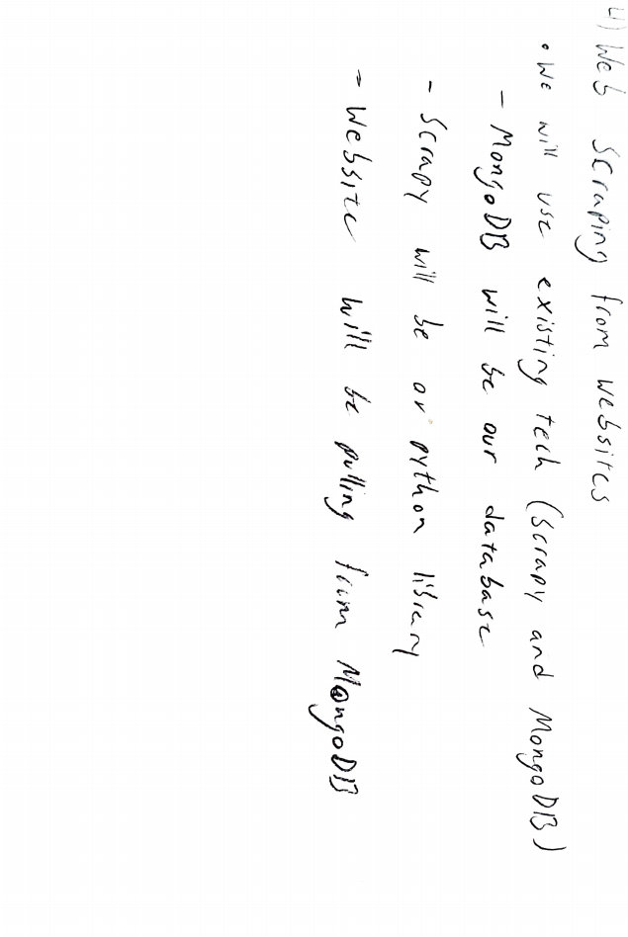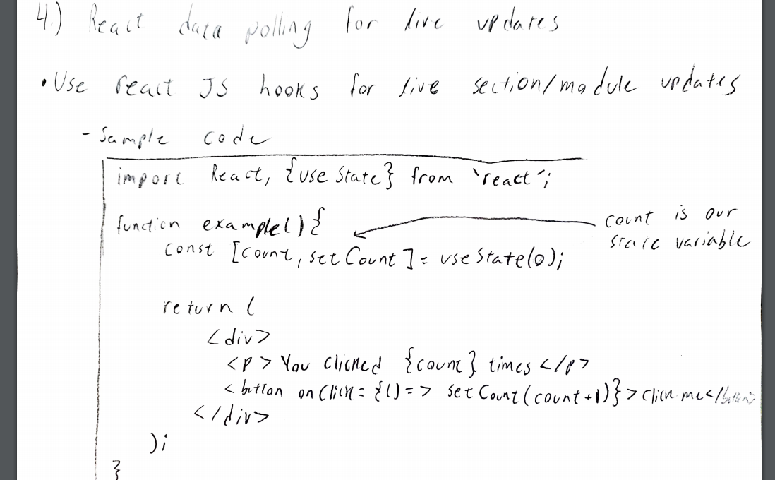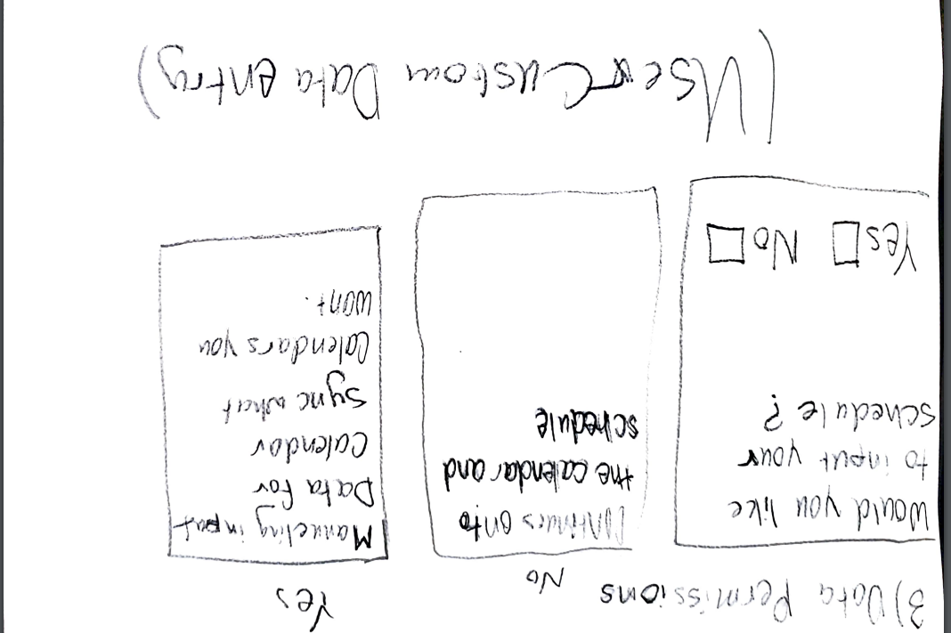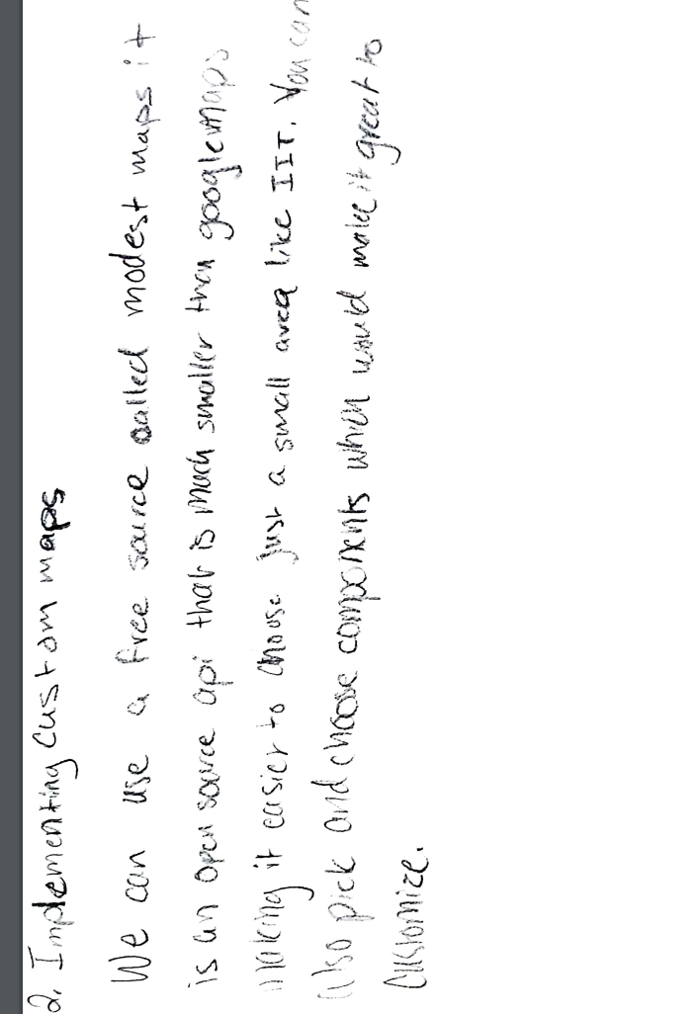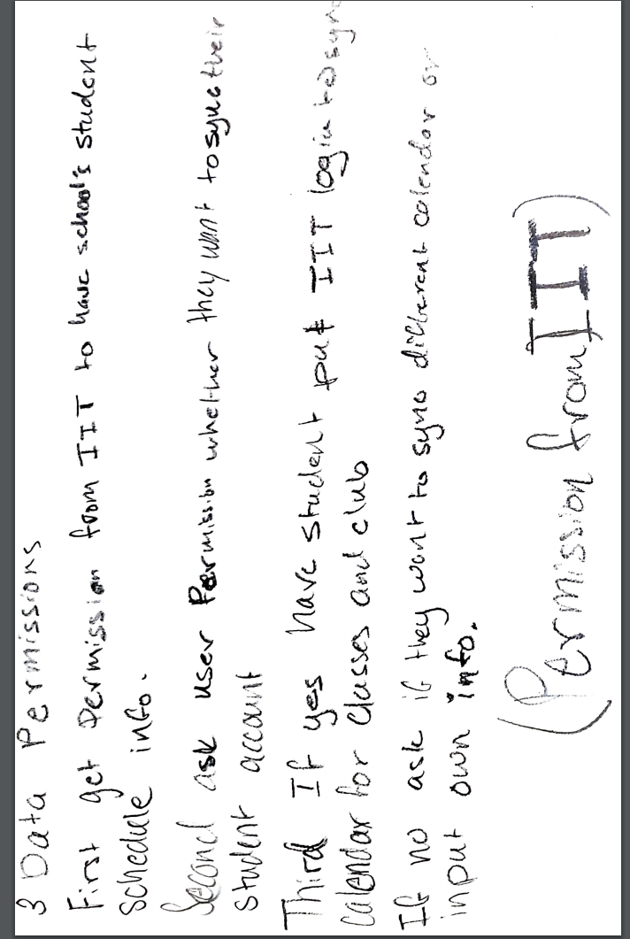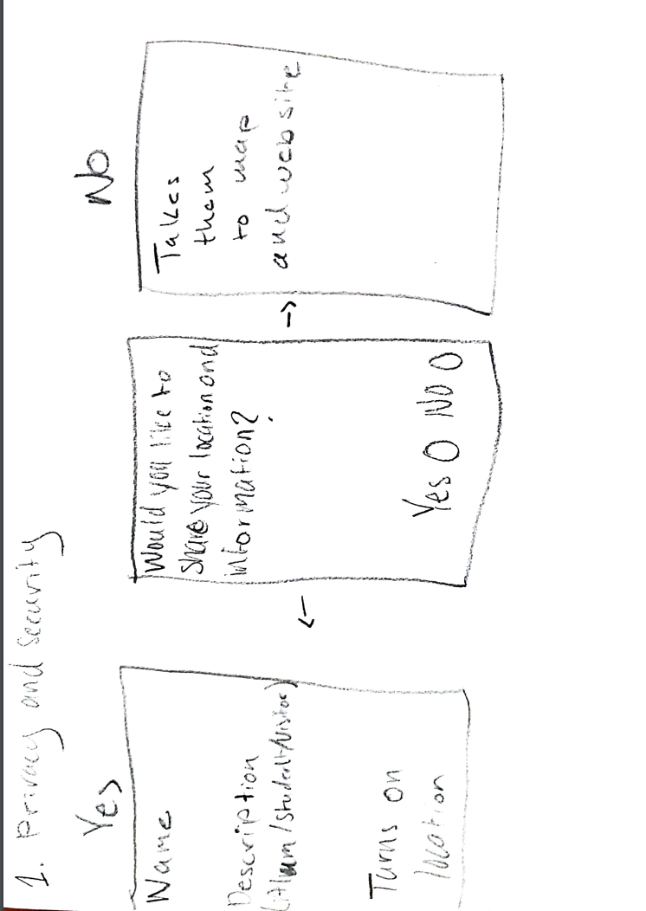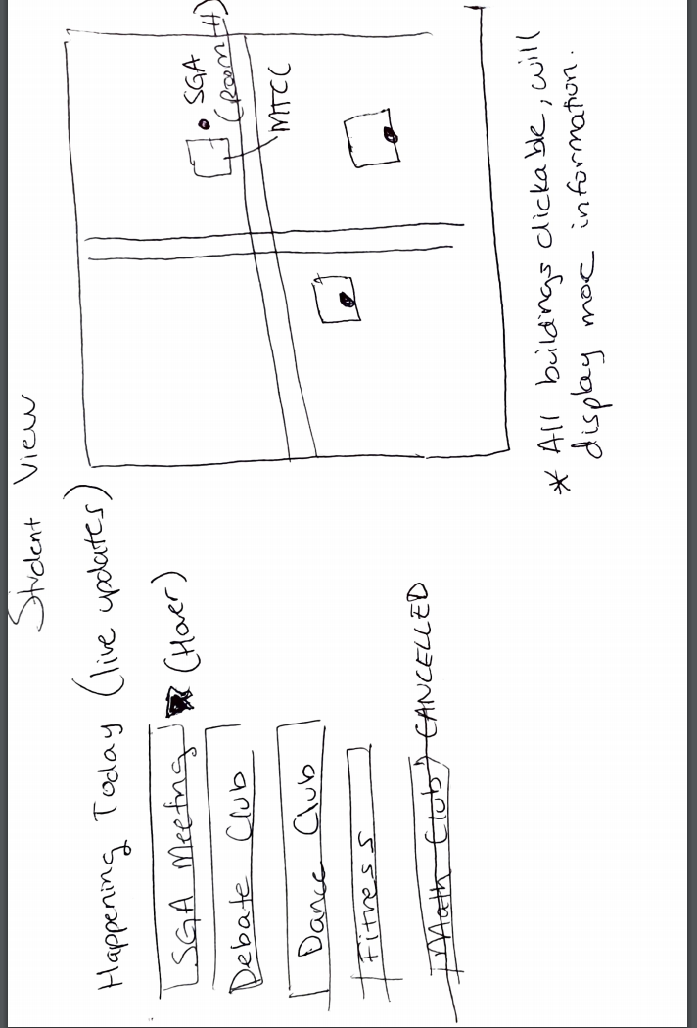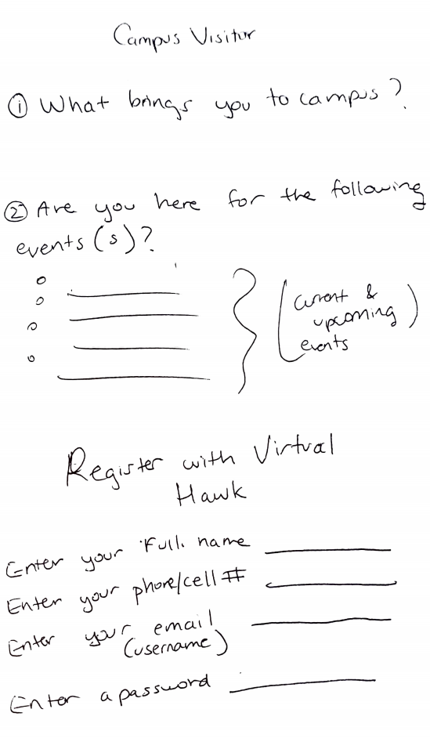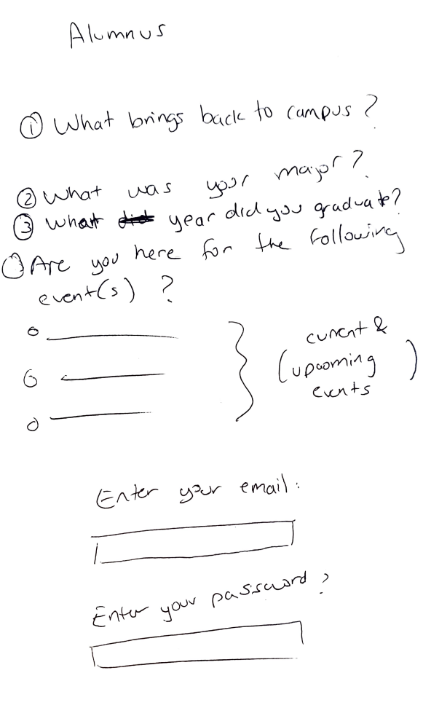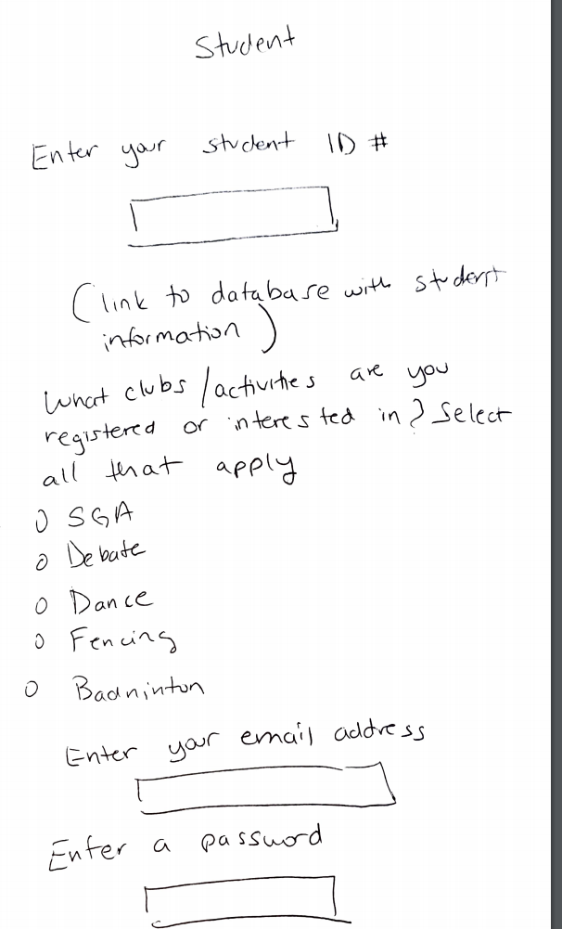

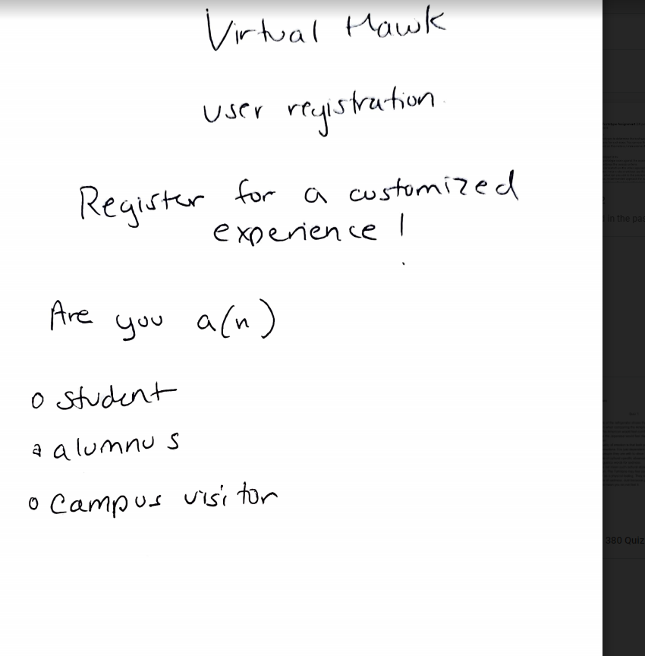

-------------------------------------------------------------------------------------------------------------------------------

* Consider how elements from the other approaches can be added to the selected solution to make it more robust without sacrificing internal consistency and elegance (in other words… what can you add to the solution without messing the whole thing up?)
* Elements we can add to the solution without ruining our project can be apis. This means using the already existing api to help boost our prototype. Already existing apis will help us implement many things into our project without ruining what we already have.
* Outline the final, recommended approach for each issue.
* Problem one, is the privacy and security of the campus and user. Solution one, what we are making is a user registrar doing this will allow us to keep data on who is using our website. Along with that we can gather data on what people are doing on the campus and why they are there.
* Problem two is implementing custom maps. Solution two, ways we can make maps is using free source maps online along with Google maps implementing. Some open source apis we can use are modest maps and leaflet.
* Problem three is about Data Permissions. Solution three, we have to get permission from IIT first to have the students’ after that we have to get the users’ permission with a pop up on whether they want to sync their info. Then students have to sign in with the IIT login if yes.
* Problem four is live updates, We can do react data polling for live updates using react JS hooks for live section updates.
* Problem five is data scraping for this we will be using existing scrape teach. MonogoDb will be our database scrapy will be on python library websites will be pulling from MongoDb.
* Did the tests reveal any ethical issues? For example, would the idea cause any population undue harm, put them at risk, or make them feel uncomfortable?
* You should now have a single concept direction with tested / validated functions and features.

Submit your solution for the second release (in the deliverables folder in team drive). This should include a general description of the solution. Then outline the different approaches and prototypes you developed for each issue. Finally, describe your decision making: Why did you choose one approach over the others? The document should be five pages or less in length. Include relevant pictures of the prototype and the prototype testing.